**Ball Experiment:** black-and-white videos of a moving circle, where the 2D trajectory is sampled from a GP with radial basis function (RBF) kernel. The goal is to reconstruct the correct underlying trajectory in the two-dimensional latent space from the frames in pixel space; The graph tracks the latent space trajectory; Frames of each test video are overlaid and shaded as shown by the images

**VAE:**

**Epoch 1000**: elbo -1848.7374

Recon term: -1613.943359375. KL term: -234.7941131591797.

VAE posterior variance range: min 0.0007431063568219543, max 0.12239756435155869

VAE posterior mean range: min -5.145145416259766, max 5.670657634735107

GP approx posterior variance range: min 0.0007425546646118164, max 0.1090499758720398

GP approx posterior mean range: min -5.066817283630371, max 5.356354236602783

**MSE : 1125.3777947952156**

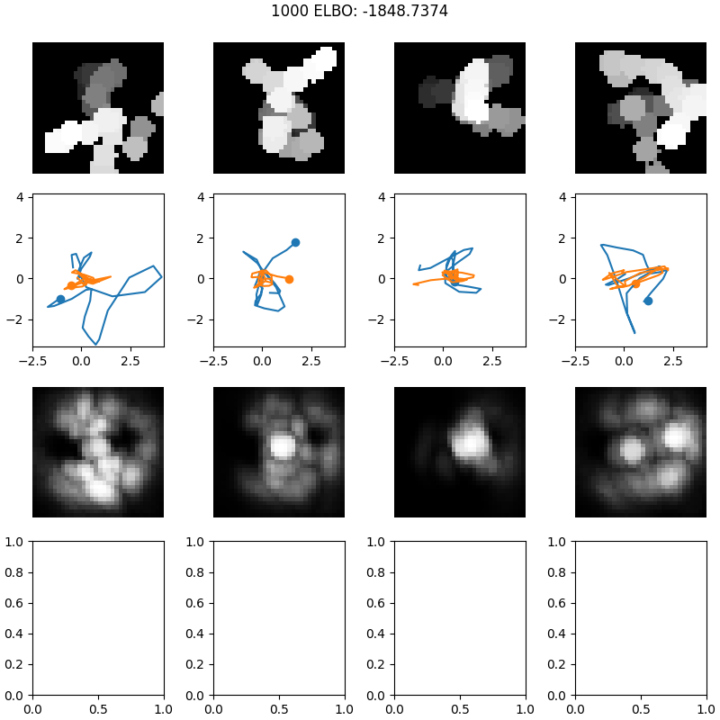

**Epoch 5000**: elbo -762.7243

Recon term: -502.0693054199219. KL term: -260.655029296875.

VAE posterior variance range: min 0.00016253255307674408, max 0.10270331799983978

VAE posterior mean range: min -4.715208053588867, max 5.329746246337891

GP approx posterior variance range: min 0.00016236305236816406, max 0.09313786029815674

GP approx posterior mean range: min -4.612941741943359, max 5.1514482498168945

**MSE : 1072.4582549322745**

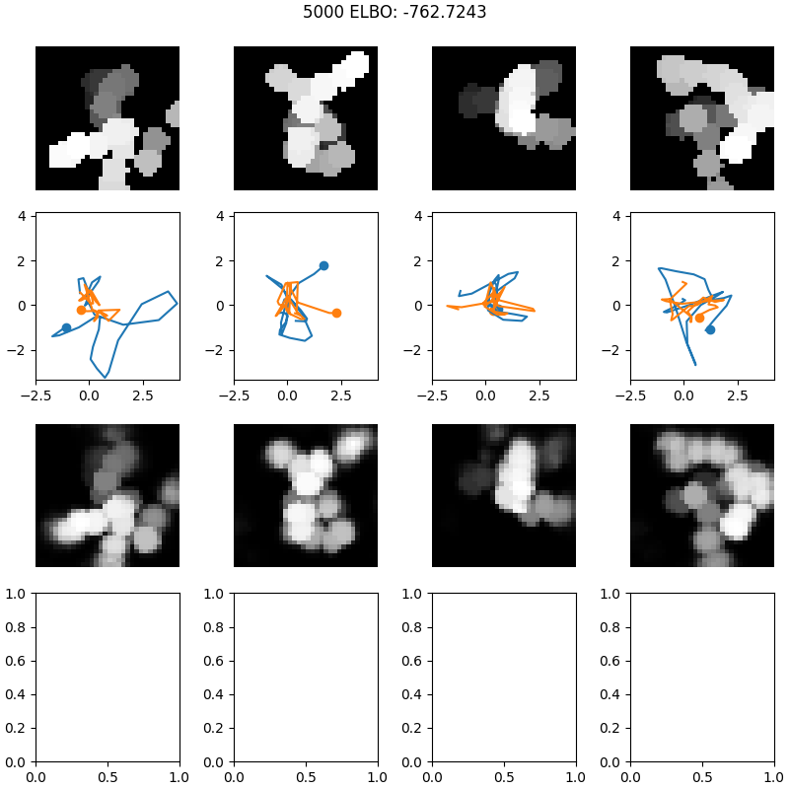

**Epoch 10000**: elbo -512.32623

Recon term: -253.3309783935547. KL term: -258.9952697753906.

VAE posterior variance range: min 8.075094228843227e-05, max 0.03582882881164551

VAE posterior mean range: min -5.067218780517578, max 4.884614944458008

GP approx posterior variance range: min 8.058547973632812e-05, max 0.03458958864212036

GP approx posterior mean range: min -5.009392738342285, max 4.84587287902832

**MSE : 1077.9480308001002**

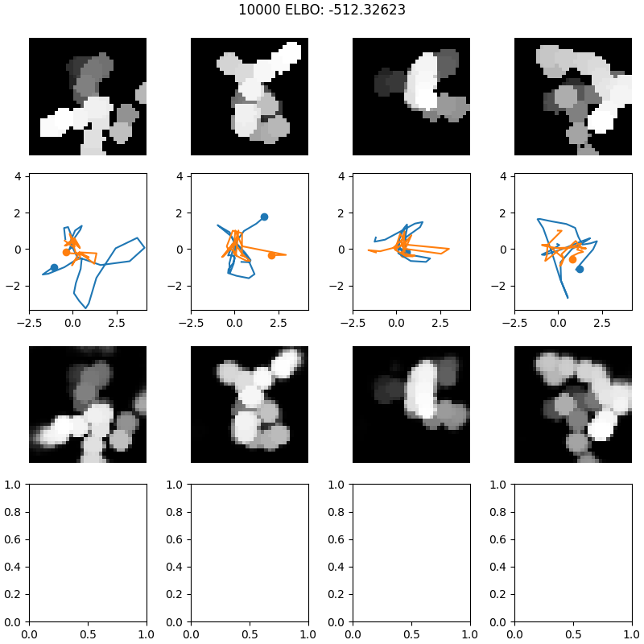

**Epoch 15000**: elbo -443.48813

Recon term: -183.89511108398438. KL term: -259.59295654296875.

VAE posterior variance range: min 5.704955765395425e-05, max 0.0218430757522583

VAE posterior mean range: min -5.287045001983643, max 4.645557403564453

GP approx posterior variance range: min 5.698204040527344e-05, max 0.021376311779022217

GP approx posterior mean range: min -5.234817981719971, max 4.597688674926758

**MSE : 1071.476767300964**

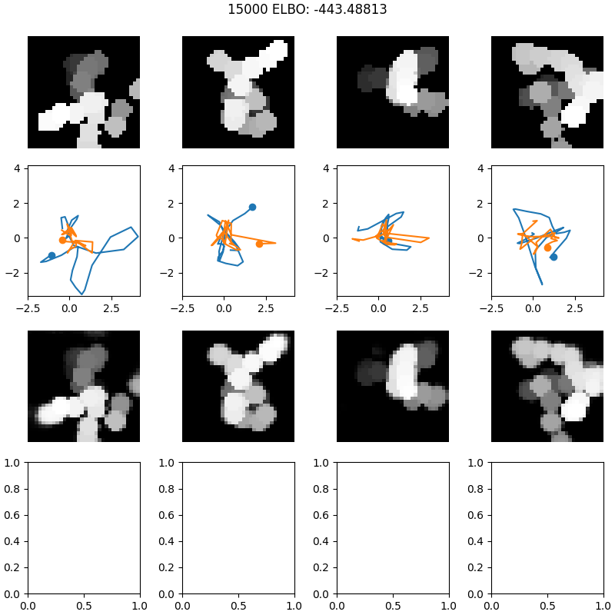

**Epoch 25000**: elbo -394.45218

Recon term: -134.42227172851562. KL term: -260.0299072265625.

VAE posterior variance range: min 3.892423410434276e-05, max 0.02373119443655014

VAE posterior mean range: min -5.335291862487793, max 4.130431175231934

GP approx posterior variance range: min 3.886222839355469e-05, max 0.02318108081817627

GP approx posterior mean range: min -5.29853630065918, max 4.102314472198486

**MSE : 1053.8673812353268**

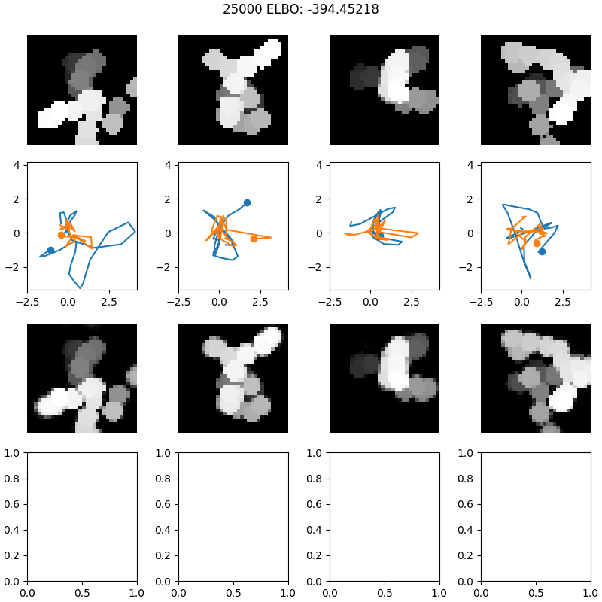

**SVGP-VAE_Titsias:**

**Epoch 1000**: elbo -1915.2317

Recon term: -1784.2684326171875. KL term: -130.96327209472656.

L2 elbo term: -232.19436645507812. CE term: 101.23108673095703.

VAE posterior variance range: min 0.005311078391969204, max 0.3676164448261261

VAE posterior mean range: min -7.608111381530762, max 7.769867897033691

GP approx posterior variance range: min 0.0038535199128091335, max 0.0970543697476387

GP approx posterior mean range: min -7.69872522354126, max 7.434299468994141

MSE : **799.244394940883**

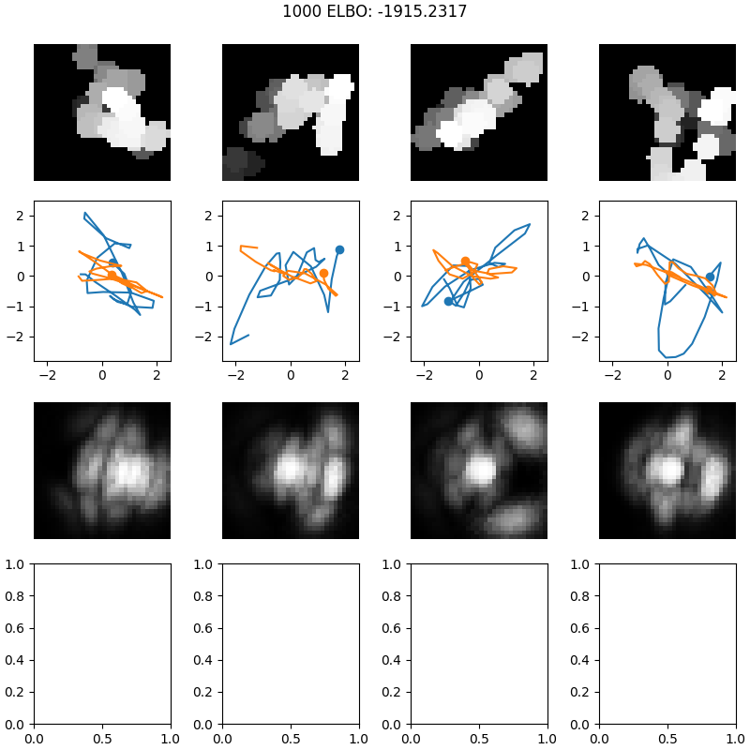

**Epoch 5000**: elbo -764.5116

Recon term: -630.8530883789062. KL term: -133.6585693359375.

L2 elbo term: -215.6261444091797. CE term: 81.96756744384766.

VAE posterior variance range: min 0.001111591118387878, max 0.3891196846961975

VAE posterior mean range: min -7.786365032196045, max 7.312774181365967

GP approx posterior variance range: min 0.0009216433973051608, max 0.047014735639095306

GP approx posterior mean range: min -8.012187957763672, max 7.183625221252441

**MSE : 85.7471398179145**

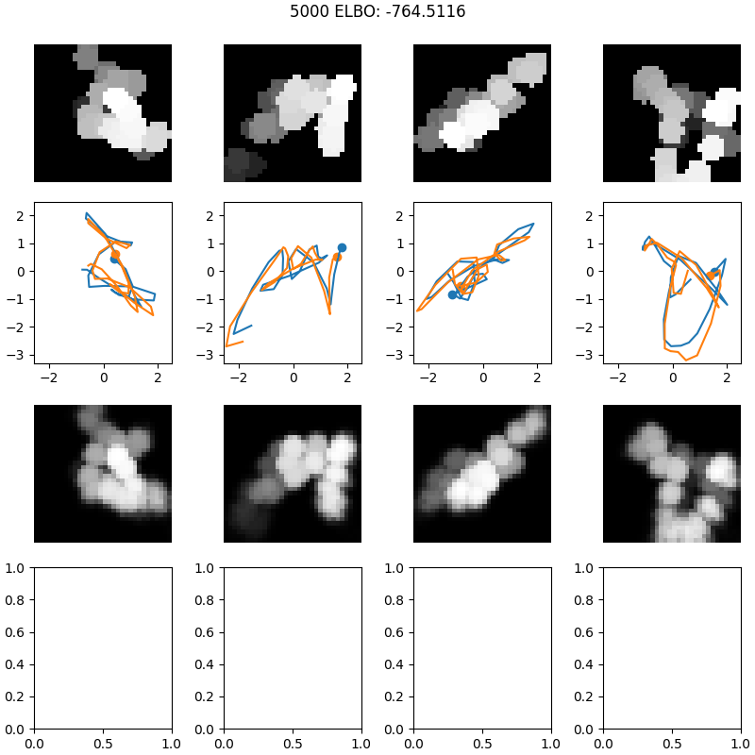

**Epoch 10000**: elbo -612.0203

Recon term: -474.8700866699219. KL term: -137.15028381347656.

L2 elbo term: -227.8368377685547. CE term: 90.68656921386719.

VAE posterior variance range: min 0.0015093630645424128, max 11.21891975402832

VAE posterior mean range: min -7.906118392944336, max 7.095048904418945

GP approx posterior variance range: min 0.001118239713832736, max 0.0498245507478714

GP approx posterior mean range: min -7.750205993652344, max 6.936990261077881

**MSE : 18.595205667679476**

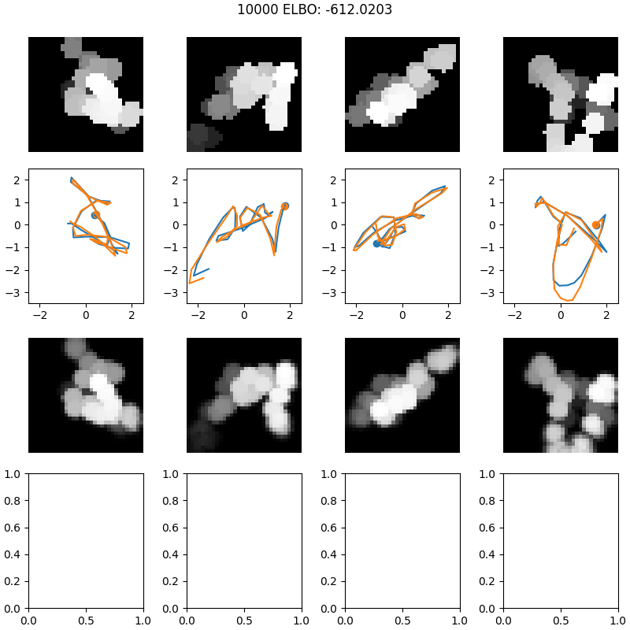

**Epoch 15000**: elbo -580.5533

Recon term: -443.7978820800781. KL term: -136.75543212890625.

L2 elbo term: -225.69300842285156. CE term: 88.93756866455078.

VAE posterior variance range: min 0.0019033729331567883, max 35.72823715209961

VAE posterior mean range: min -7.788362503051758, max 6.591612339019775

GP approx posterior variance range: min 0.0013198192464187741, max 0.046295300126075745

GP approx posterior mean range: min -7.260212421417236, max 6.539665699005127

**MSE : 10.610115910070093**

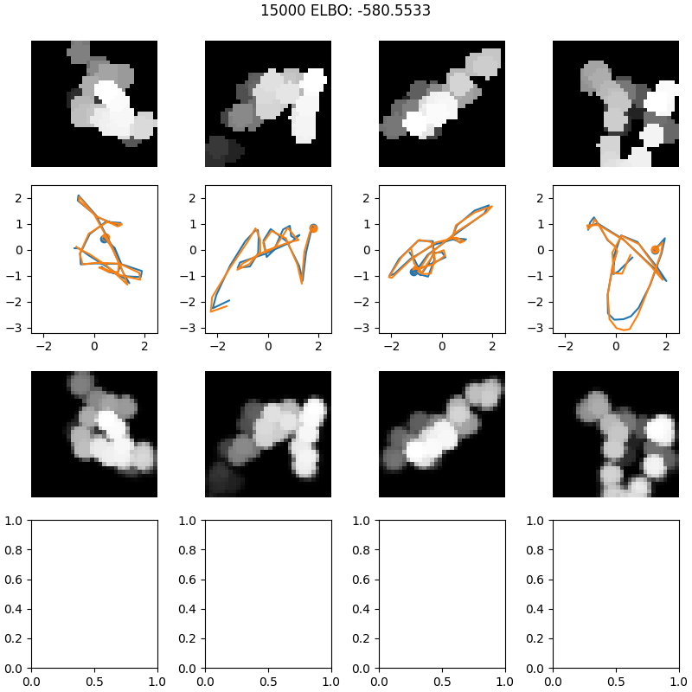

**Epoch 25000:** elbo -573.4667

Recon term: -436.3981018066406. KL term: -137.068603515625.

L2 elbo term: -237.66180419921875. CE term: 100.59321594238281.

VAE posterior variance range: min 0.0020354639273136854, max 91.5702133178711

VAE posterior mean range: min -7.688401699066162, max 5.893623352050781

GP approx posterior variance range: min 0.0013207466108724475, max 0.033508338034152985

GP approx posterior mean range: min -6.819155693054199, max 6.206866264343262

**MSE : 8.07269818654036**

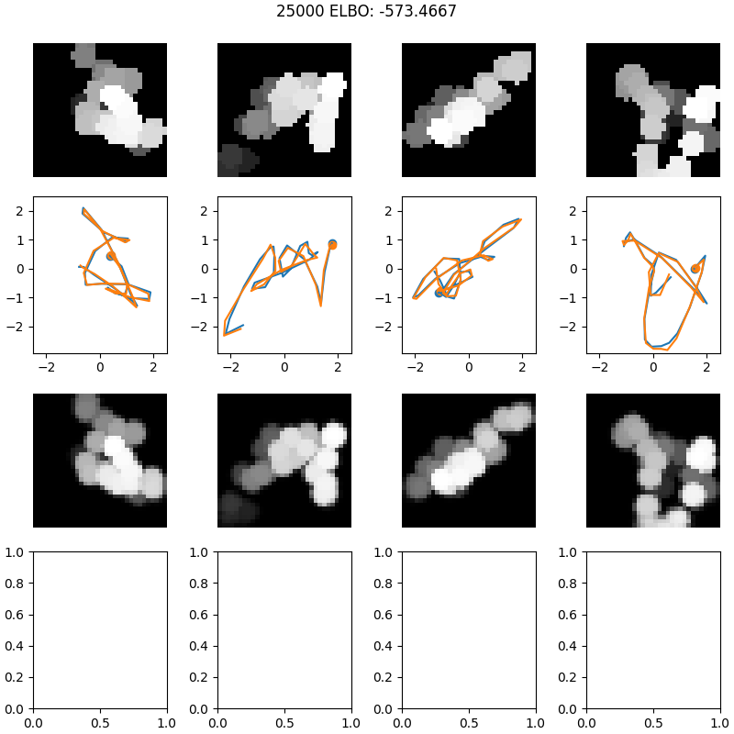

**Conclusion**: The VAE and the SVGP-VAE were both able to reconstruct the image, but the VAE tracked some other latent relationship that wasn’t representative of the time dependent trajectory, as displayed by the differences between the ground truth (blue) and inferred trajectories (orange) in the graph.

Next we tested the generation capabilities of the SVGP-VAE with the MNIST data set

**MNIST Experiment**: use rotated MNIST digits in a conditional generation task. The task is to condition on a number of digits that have been rotated at different angles and to generate an image of one of these digits rotated at an unseen angle.

**SVGP-VAE_Titsias:**

**Epoch 10**, opt regime joint, mean ELBO per batch: 1.987686295142394e+26

MSE loss on train set for epoch 10 : 0.04683793333239043

MSE loss on eval set for epoch 10 : 0.04809317995337563

**MSE loss on test set** for epoch 10 : 0.04907857458901491

**Conditional generation MSE loss on test set for epoch 10**: 0.06932920300694276

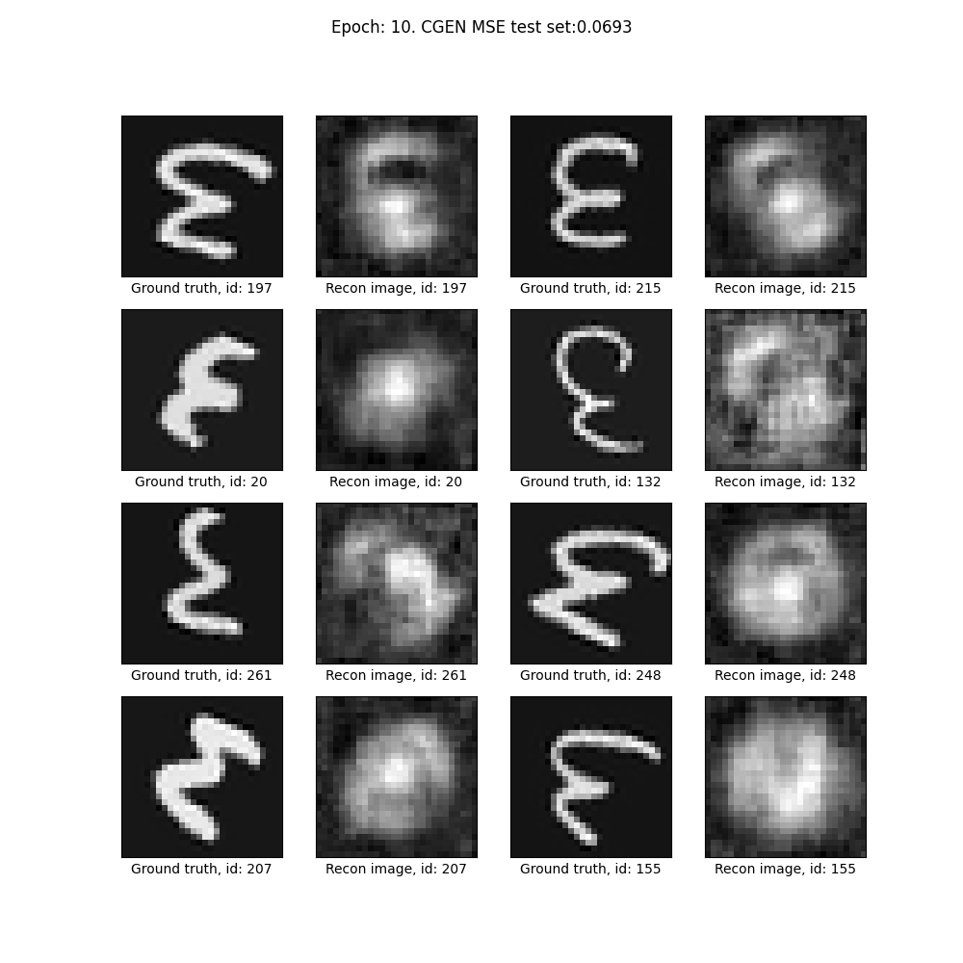

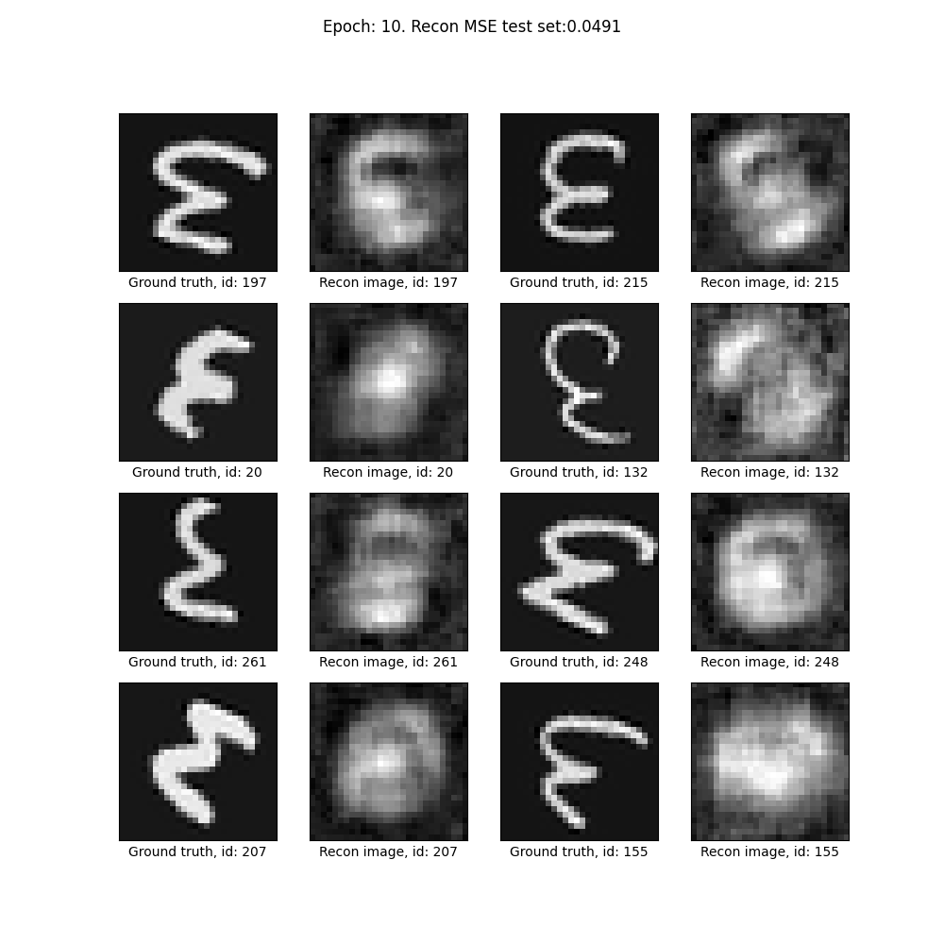

**Epoch 200**, opt regime joint, mean ELBO per batch: 4.748376812174388e+49

MSE loss on train set for epoch 200 : 0.00663615036118836

MSE loss on eval set for epoch 200 : 0.061568470346505345

**MSE loss on test set** for epoch 200 : 0.016512100629141196

**Conditional generation MSE loss on test set for epoch 200**: 0.029384675923472808

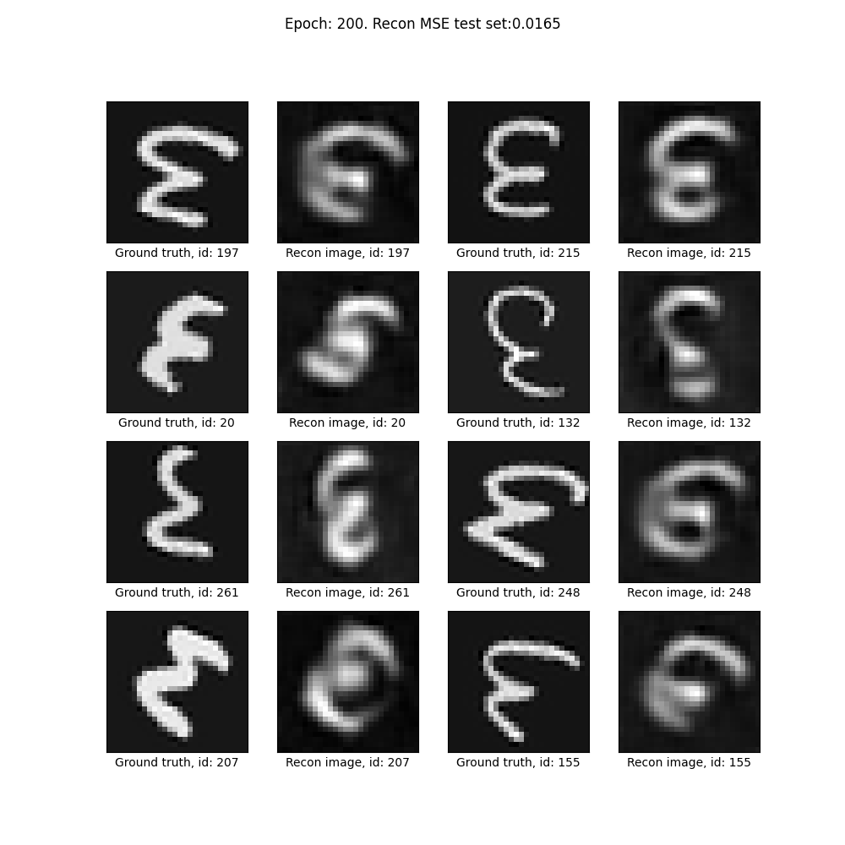

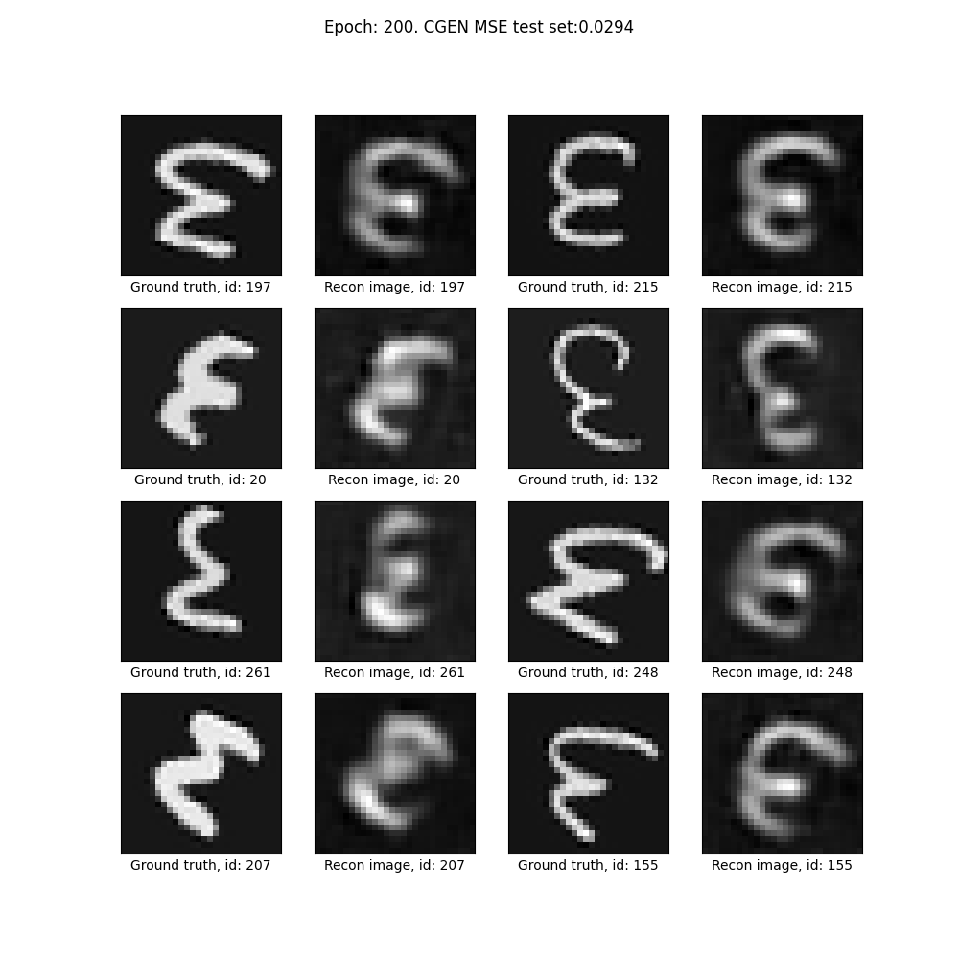

**Epoch 500**, opt regime joint, mean ELBO per batch: 3.3007378402564316e+60

MSE loss on train set for epoch 500 : 0.004499727763541254

MSE loss on eval set for epoch 500 : 0.06694820033720612

**MSE loss on test set** for epoch 500 : 0.018733483927779855

**Conditional generation MSE loss on test set for epoch 500**: 0.027842656384492015

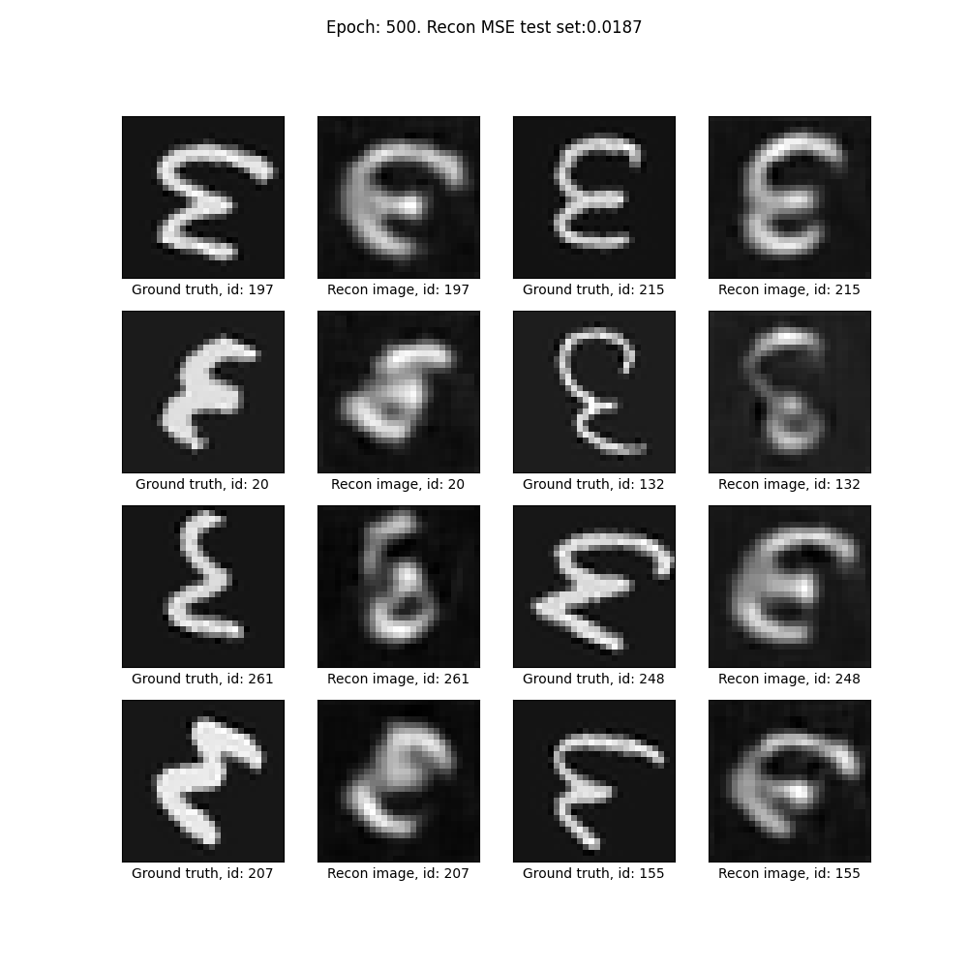

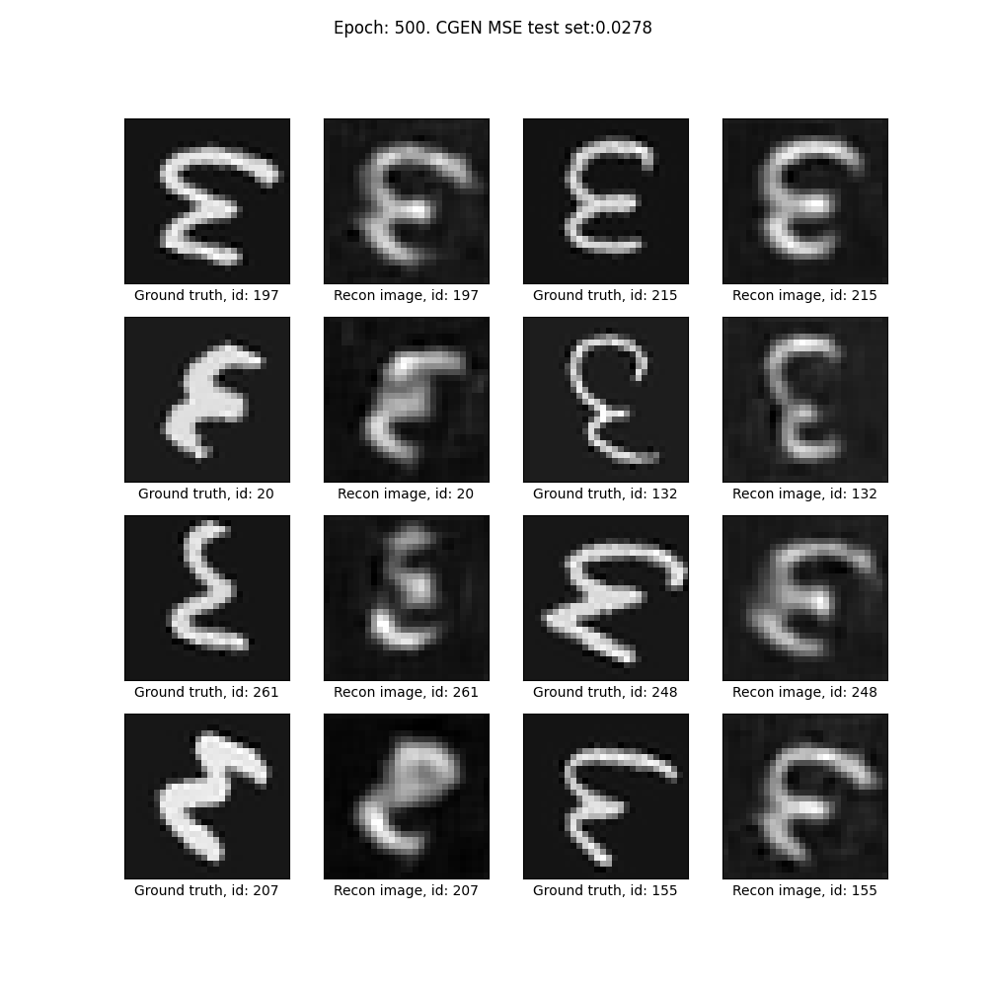

**Best cgen MSE on test set**

**Epoch 810**, opt regime joint, mean ELBO per batch: 2.2049763077210305e+69

MSE loss on train set for epoch 810 : 0.0036517766017506296

MSE loss on eval set for epoch 810 : 0.06722279756297418

**MSE loss on test set for epoch 810** : 0.018947469736444036

**Conditional generation MSE loss on test set for epoch 810**: 0.02643877447682447

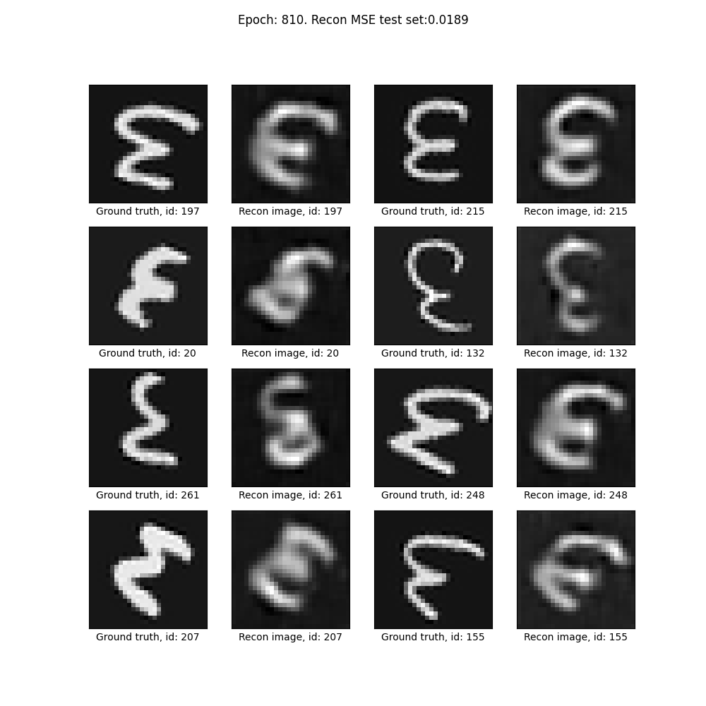

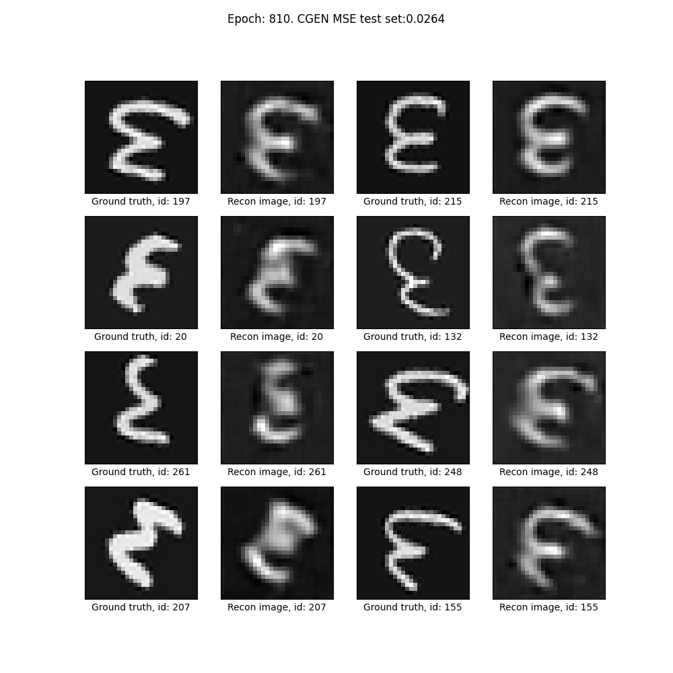

**Epoch 1000**, opt regime joint, mean ELBO per batch: 1.7487966041988747e+74

MSE loss on train set for epoch 1000 : 0.003111199141553196

MSE loss on eval set for epoch 1000 : 0.066607771560117

**MSE loss on test set** for epoch 1000 : 0.01857291968359223

**Conditional generation MSE loss on test set for epoch 1000**: 0.026503438391583565

